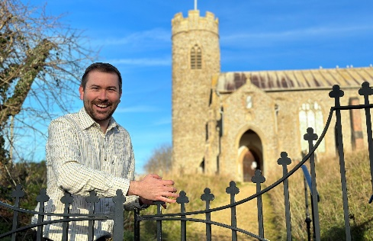
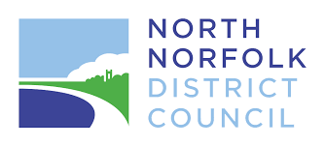

District Councillor Report – Cllr Callum Ringer
Serving the parishes of: Aylmerton ; Baconsthorpe ; Bodham ; East Beckham ; Gresham ; Hempstead ; Little Barningham ; Matlaske ; Plumstead ; West Beckham
January 2026
Wishing you all a happy new year
Gresham Ward – Joint Parish Councils meeting
Over the course of attending parish council meetings across the Gresham Ward, it has become clear that many of the same issues arise time and again. Matters such as speeding and road safety, highways, housing, planning, policing, flooding, and wider infrastructure challenges are affecting villages across the ward, often in very similar ways.
While each parish has its own character and priorities, there is real potential strength in coming together to share experiences, knowledge, and good practice. Many councils are grappling with the same problems, asking the same questions, and engaging with the same organisations. A joint approach could help avoid duplication, strengthen collective understanding, and provide a clearer voice when engaging with partner agencies.
There is also a practical benefit. It is far easier to invite a police officer, highways engineer, district or county council officer, or other relevant representative to attend a single joint meeting, rather than asking them to attend multiple individual parish meetings. This approach has worked well in other areas and has proven beneficial for parish councils and partner organisations alike.
With that in mind, I am exploring the idea of holding a joint parish council meeting for the Gresham Ward. The aim would be to hold an evening session, with a short introduction, followed by a themed discussion led by a relevant guest speaker, and time for questions and shared discussion.
To help shape this properly, I am asking all parish councillors to complete the short survey. The survey is anonymous: it asks only which parish council you represent, whether you would be interested in attending, and which themes you would most like to see covered. There is also space to suggest other topics.
If there is sufficient interest and the first meeting proves useful, I would look to repeat the format later in the year, potentially in the autumn.
Please complete survey here: https://www.surveymonkey.com/r/TWK8LD3

A148 Highways Matters
With an inquest date being set following the tragic deaths in High Kelling in December 2024, we expect to see the full proposals for highways improvements along the A148 from Holt through to the Felbrigg Roundabout later in the year. Those in the most directly impacted parishes will hear in advance of some of these proposals at a meeting being organised by Steff Aquarone MP which will be attended by key highways and police representatives. More on this to follow…..
Local Government Reorganisation – Consultation Now Open
At a Cabinet meeting on Monday, January 5, Councillors discussed and agreed the Council's statutory consultation submission around the Norfolk Local Government Reorganisation. The full submission can be seen here:
north-norfolk-district-council-response-to-government-consultation-on-local-government-reorganisation-in-norfolk.pdf
Communities across Norfolk are encouraged to take part in a once-in-a-generation consultation on the future of Local Government in the county. The consultation runs until Sunday, January 11, 2026, and you can complete it here - Norfolk and Suffolk Consultation.
Norfolk County Council Elections – May 7th 2026
The Previously delayed Norfolk County Council elections (initially supposed to be held in May 2025!) are not potentially going to be held after all, a year late. The government has put the final decision in the hands of each individual council, and therefore the we should learn later this month whether the elections are going ahead. All the parishes in the Gresham Ward will become part of the new ‘Erpingham’ division. Currently the villages that I represent are split between Holt division and Melton Constable division but with the Holt division boundaries changing significantly and the Melton Constable division being abolished entirely all will fall into the Erpingham division. I am very keen that these elections DO go ahead.
North Norfolk Local Plan 2025-2040
North Norfolk District Council has formally adopted its new Local Plan, which will guide development across the district up to 2040.
The Plan has been shaped by evidence, public consultation, and independent examination, and has been confirmed by the Planning Inspectorate as sound and legally compliant. It replaces previous planning policies and will now be used to determine planning applications.
The Local Plan sets out where new housing and employment should be focused, alongside policies to protect North Norfolk’s environment, support infrastructure, and promote high-quality, sustainable development.
For parish councils, the adopted Plan provides a clear framework for responding to planning applications and helps ensure a plan-led approach to development. The full documents can be seen on the link below
https://www.north-norfolk.gov.uk/tasks/planning-services/planning-policy/local-plan/
Email: callum.ringer@north-norfolk.gov.uk
I’m always happy to deal with any issues between meetings—please don’t hesitate to get in touch.

