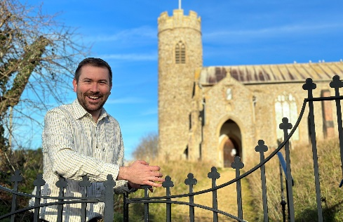
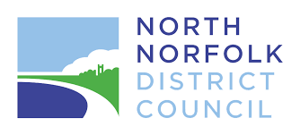

District Councillor Report – Cllr Callum Ringer
Serving the parishes of: Aylmerton ; Baconsthorpe ; Bodham ; East Beckham ; Gresham ; Hempstead ; Little Barningham ; Matlaske ; Plumstead ; West Beckham

November and December 2025

Gresham Ward – Joint Parish Councils meeting
As District Councillor for the past two and a half years, I’ve spent a great deal of time touring my nine parishes and meeting with parish councils. What strikes me is how often the same issues come up: highways and road safety, housing and planning, environmental concerns, biodiversity, and other shared challenges.
It has made me wonder whether parish councils might benefit from having a forum to discuss these matters together. In other areas, similar collaborative approaches have proved successful — helping councils share good practice, discuss shared challenges, and even achieve economies of scale that save time and money.
A joint forum might also make it easier to secure attendance from key partners. Police representatives, Highways officers, or senior council officers are often more able to attend when they can speak to several parishes at once, rather than visiting each individually.
With this in mind, I am considering organising a joint meeting in the new year with representatives from all nine parish councils — initially as a one-off, but potentially something we could repeat if it proves useful.
I would very much welcome your thoughts and views on this idea.
Local Government Reorganisation – Consultation Now Open
The Government has launched a major public consultation on the future structure of local government in Norfolk. It proposes replacing the current county, city, district and borough councils with new unitary authorities responsible for all local services.
Three options are being consulted on:
- Three Councils – East Norfolk, West Norfolk, Greater Norwich
Proposed jointly by six district/borough councils, including North Norfolk.
- Two Councils – Norwich & East Norfolk; West & North Norfolk
Proposed by South Norfolk District Council.
- One Council for the Whole of Norfolk
Proposed by Norfolk County Council.
Recommended Option
North Norfolk District Council, alongside five neighbouring councils, strongly supports the three-council model. This structure is considered the most effective for:
- Ensuring strong local accountability
- Allowing services to be tailored to the distinct needs of coastal, rural and urban areas
- Protecting key priorities for North Norfolk such as coastal defence, climate adaptation, and tourism
- Providing a balanced scale—neither too large nor too fragmented
This proposal also has cross-party support from eight Norfolk MPs.

Have Your Say
The consultation is open until Sunday, 11 January 2026.
Responses can be submitted online via the Norfolk and Suffolk Consultation website.
Paper copies are available from local councils, and library computers can be used for online submissions.
Next Steps
The Government is expected to make its decision in spring 2026, with any new authorities taking effect in April 2028 following shadow elections in May 2027.
Town and parish councils are encouraged to promote the consultation locally and ensure residents’ views are represented.
You can find more details about the proposals via Future Norfolk.
The Government’s consultation runs until Sunday, January 11, 2026, and can be completed here Norfolk and Suffolk Consultation
Affordable Housing Update – West Beckham Exception Scheme
It was a real pleasure to welcome so many parish councillors to the new affordable housing site in West Beckham during early August. I am pleased to report that residents have now moved in and are settling into the village, marking a significant milestone for this community-led project.
This development is one of our district’s “exception” housing schemes—homes delivered on land not normally allocated for housing, and reserved for people with a local connection to the parish or nearby area. This approach ensures that the homes directly benefit those with genuine ties to the community.
Feedback from the West Beckham project has been very positive, and conversations are already taking place with several other parishes exploring the possibility of bringing forward similar schemes. We are hopeful that this momentum will help deliver more locally tailored, affordable homes across North Norfolk in the months and years ahead.

Independent Custody Volunteers Needed
At a recent meeting of the Norfolk Police and Crime Panel, concern was raised about the low number of volunteers coming forward from North Norfolk to support the Aylsham Police Investigation Centre. The scheme relies on Independent Custody Volunteers (ICVs) who make unannounced visits to police stations to check on the welfare and treatment of detainees. Their work provides important public oversight and helps ensure detainees are treated with dignity and in line with their legal rights.
If any parish councillors or members of the public are interested, please do pass this opportunity on.

Norfolk Churches Trust Sponsored Cycle Ride
On Saturday 13 September, the annual Norfolk Churches Trust Cycle Ride took place, raising vital funds to support the upkeep of our churches. I cycled on behalf of Bodham Church alongside Kathryn and we raised £700 which will be split between Bodham church at the NCT
It was a wonderful community event — we cycled 60 miles, taking in 50 churches along the way. We are very grateful to all our sponsors for their support, and I’d also like to congratulate everyone who took part across the county, whether that be cycling, walking or manning the church signing in partipants.

Email: callum.ringer@north-norfolk.gov.uk
I’m always happy to deal with any issues between meetings—please don’t hesitate to get in touch.

