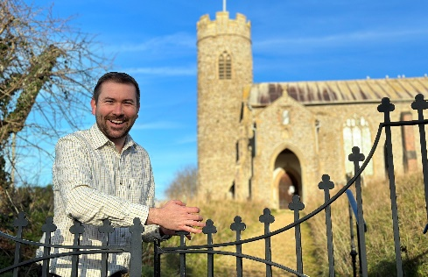


District Councillor Report – Cllr Callum Ringer
Serving the parishes of: Aylmerton ; Baconsthorpe ; Bodham ; East Beckham ; Gresham ; Hempstead ; Little Barningham ; Matlaske ; Plumstead ; West Beckham

September 2024
Local Government Reorganisation
On 17 September, I will be voting on the council’s position regarding the Government’s proposals for local government reorganisation. The expectation is that NNDC will continue to object to the process entirely, as many of us feel it is being imposed without sufficient local input or consideration. However, we also have to face the reality that reorganisation will go ahead, and the council is therefore likely to support a three-unitary council approach as the most workable model for Norfolk should it proceed.
West Beckham Affordable Housing
It was a real pleasure to welcome so many parish councillors to the new affordable housing site in West Beckham during early August. I hope this visit acts as a catalyst for similar future schemes across the district. These are known as “exception” schemes—they can only be delivered on land not normally allocated for housing, and they require a local connection for those applying. This ensures that homes go to people with genuine ties to the parish or surrounding area. I am very pleased to report that in Beckham, families have now been assigned properties and will be moving in shortly—a positive step in addressing local housing need.
Progress on the A148 Road Safety campaign
Since the tragic fatalities of Sheila and Campbell Welsh, I along with other local councillors and Steff Aquarone have called for a comprehensive review of the A148 from Holt Roundabout through to the Felbrigg Roundabout. Following a stakeholder meeting in February highways agreed to this. Over the summer highways have been reviewing traffic data – not just vehicle movements but pedestrian and cyclists too. £20k has been extracted from the developers of the old Pineheath nursing home which will specifically contribute towards enhanced pedestrian crossing. Draft proposals should be known later in the Autumn but the final sign off – we are told – will need to await any recommendations from the inquest for which no date has been set.

Graveyards at Risk of Coastal Erosion
Across England, a number of coastal graveyards are at risk of loss to erosion, including three in Happisburgh, Trimingham and Mundesley. In response, Coastwise, working with the Diocese of Norwich, has commissioned a study looking at policies, legislation, and practical options for communities facing this issue.
Graveyards are of deep cultural and emotional significance, yet there are currently no plans in place to manage them when threatened by erosion. The report sets out potential options—ranging from doing minimum, defending, ceasing use, relocating, or long-term management—and highlights the importance of community involvement in decision-making.
Workshops and engagement events will continue in coastal communities to help shape local transition plans, ensuring respectful and proactive approaches for the future.

Norfolk Churches Trust sponsored cycle ride
On Saturday 13 September, the annual Norfolk Churches Trust Cycle Ride will take place, raising vital funds to support the upkeep of our churches. I’ll be cycling on behalf of Bodham Church, and if you’d like to sponsor me I’ll include a link. It’s always a wonderful community event, and I’d like to wish good luck to everyone taking part across the county.
https://www.justgiving.com/page/callum-kathryn-bodhamchurch
Email: callum.ringer@north-norfolk.gov.uk
I’m always happy to deal with any issues between meetings—please don’t hesitate to get in touch.

