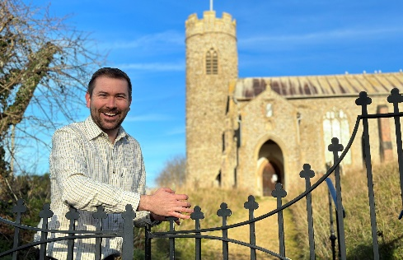
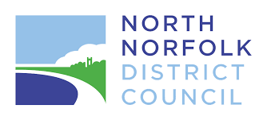

District Councillor Report – Cllr Callum Ringer
Serving the parishes of: Aylmerton ; Baconsthorpe ; Bodham ; East Beckham ; Gresham ; Hempstead ; Little Barningham ; Matlaske ; Plumstead ; West Beckham

Councillor Report January 2025
Reorganisation of Local Government
Since my last report it has been confirmed that the elections to Norfolk County Council have been cancelled. This was at the request of the Conservative run NNDC and ratified by the Labour government. It is worth pointing out that the Lib Dems do not support that decision. North Norfolk District Council is not due to have elections until 2027.
So, what does the future hold? One thing seems certain, Parish and Town councils will remain. I know that some parishes have started discussing greater collaboration in a way to improve efficiency and save money. With a shortage of qualified clerks that might be a way forward. That’s for parishes to think about themselves.
North Norfolk District Council and Norfolk County Council will cease to exist at some point later this decade. They will be replaced by a ‘unitary’ authority which will see most services from both looked after by a single council. This may have some advantages in that many people do not know which council is responsible for what service (even many councillors!) however it will be over a larger geographical area. Whereas Norfolk has 8 district councils and 1 county, it will be replaced by (probably) three separate unitary councils. On boundaries which are yet to be determined though draft proposals are expected shortly.
In addition there will be an elected Mayor for Norfolk and Suffolk as part of a ‘combined county authority’ what powers they will have are to be determined. Ultimately though as you will note we go from three tiers of councils (Parish/Town, district and County) to three tiers of ‘councils’ in another name (Parish/Town, Unitary, and combined county mayoral authority), the latter two which will become more distant to our local communities. I am concerned by this, and ultimately I think that there is little understanding of rural areas in central government.
This issue wont go away so expect it to feature on my reports for the next couple of years at least!

A148 Road Safety Meeting
Following the tragic loss of life in High Kelling just before Christmas, I called on Norfolk County Council to conduct a comprehensive review of road safety along the extent from Holt to Felbrigg. I quickly gained the support of Steff Aquarone MP and together we organised a meeting of the key stakeholders in the area, with representatives of Norfolk Police, the Police and Crime Commissioner and Highways.
The meeting took place on the 18th February at High Kelling village hall and I was really pleased that representatives from Bodham, E&W Beckham, and Aylmerton in my ward, who are most impacted by this road, were able to attend. Everyone had the opportunity to have a say about the issues that as they see them, and there were common themes that emerged – such as the inconsistencies with speed limits, lack of lighting in key areas, poor pedestrian safety and many issues with speed, enforcement and driver distraction.
I am pleased that a full review of the road has now been agreed and the next step is a meeting with Steff, Highways and the police to take place in early April. If you would like to inform the discussion and wish to put your own views across then please email Steff (steff.aquarone.mp@parliament.uk) or myself.
I was particularly impressed with the Police and Crime Commissioner who spoke passionately about PREVENTION rather than the current County Council policy which is, to put it bluntly, to wait for someone to die. Sarah Taylor, the PCC, also invites comments and questions. Her email is opccn@norfolk.police.uk
Thanks to all those who have been involved up to now and I will keep you posted.
Food Waste collections for TRADE
In April 2025 the governments simpler cycling legislation begins to take effect for trade waste customers. This means that businesses with more than 10 employees or more FTE will be required to separate recycling and food waste. Most will have been doing this for recycling for many years however food waste is a new requirement and no one NNDC has offered.
ALL businesses will be required to do this from 2027 and for domestic premises this will be from April 2026.
For more information please visit: https://www.north-norfolk.gov.uk/tasks/environmental-services/commercial-food-waste-collection-service/
Norfolk Marathon
My latest hair brained silly idea was to sign up to the Norfolk Marathon which is on 13th April 2025. It starts in Cromer, and finishes back in Cromer conveniently by the Red Lion.
I am raising money for Bodham Playing Field and would love to be able to raise a good amount for their project to upgrade all the equipment. If 26 people sponsor a mile at £20 then I will beat my £500 target, and with a raffle in the pipeline too hopefully that will increase even more. I’m particularly keen for businesses to sponsor a mile so do let me know. You can donate via: https://donate.giveasyoulive.com/fundraising/callums-y3p-challenge

Great British Spring Clean:
The Great British Spring Clean takes place from 15th March to the 31st March. NNDC have available plenty of litter pickers, sacks, hoops and can remove all waste collected. We now have some nice snazzy signage too which was suggested by Katy at Aylmerton and is now available for all of the district to borrow. You can organise this by emailing cleansing@north.norfolk.gov.uk – please let me know too and I will join you if I can.
And Finally…. I continue to be available for any casework issues that arise so do get in touch if I can be of any assistance. Callum.ringer@north-norfolk.gov.uk

