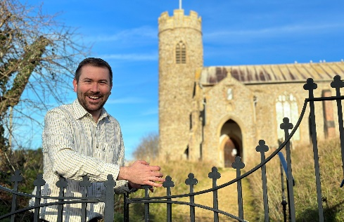


District Councillor Report – Cllr Callum Ringer
Serving the parishes of: Aylmerton ; Baconsthorpe ; Bodham ; East Beckham ; Gresham ; Hempstead ; Little Barningham ; Matlaske ; Plumstead ; West Beckham

Councillor Report January 2025
Pierre Butikofer
I was sad to learn that our former district councillor here in Gresham Ward, Pierre Butikofer passed away on Sunday 22nd December. Pierre fought a long battle against cancer with a tremendous amount of bravery, exhibiting both a wonderfully positive attitude and his characteristic good humour whilst doing so.
A celebration of Pierre’s life will take place at 11am on Friday 10th January at Cromer Crematorium. Family Flowers only though please, however donations are invited for a wonderful cause: ‘ Pillows from Pierre’ a fund set up by Sarah, in Pierre’s name, to provide additional pillows for the Norfolk and Norwich University Hospital.
On speaking about Pierre’s brave fight and the donation cause, Sarah says:
“On two occasions during those three years Pierre was hospitalised and although lucky himself to receive a pillow in hospital, he was upset to see many others have to use towels or blankets. He was concerned that when a person is unwell enough to need hospital care they could not even get a pillow to rest their head on; he was also upset to see the distress it caused relatives and friends.
So now I am fundraising to get as many pillows for the Norfolk and Norwich hospital as I can in his memory. Nothing fancy, just a pillow for a patient to rest on when in need.”
The link to the fundraising page is as follows:
https://www.justgiving.com/crowdfunding/pillowsforpierre?utm_term=dXkveMXVY
Reorganisation of Local Government
You may have seen reported in the news that the government published a white paper just before Christmas on the reorganisation of local government. This would see County and District councils replaced by mayoral combined authorities and unitary councils. For us in North Norfolk what this would mean is NNDC and NCC replaced by a unitary council. What the boundaries of this would look like, for example, are all completely unknown factors at this time. The mayoral combined authority for us would likely be a Norfolk and Suffolk Mayor. Local accountability is incredibly important and in a district council you have a representative who looks after a relatively small number of people, for myself it is 9 small parishes. I am concerned that any replacement may lead to a more distant democratic accountability much like the county council where your representative has nearly 30 parishes to look after.
Norfolk County Council elections are due to take place in May this year, and both Labour and the Conservatives at county hall look likely to call for these elections to be cancelled in light of the changes, but with so much uncertainty this seems like a bad move – and of course, our residents deserve the chance to have their say on this matter. As a result, the Liberal Democrats will be rejecting calls to hold the elections. Ultimately the decision to postpone will lay with government.
The situation is dynamic and I am sure things will have changed by my next report.
High Kelling – pedestrian fatalities
I was deeply saddened to learn of the deaths of Campbell and Sheila Welsh, in High Kelling on December 22nd. They were tragically struck trying to cross the A148 following a carol service. Although High Kelling is not in the Gresham Ward, the matter is one that effects many of us who live along this stretch. It follows a worrying trend with the deaths of Michael Rawson in 2016 and Martha Seaward in 2015 along this stretch of road – not to mention the large number of RTAs and near misses.
Following a fatal RTC in Bodham in the Autumn I called on Norfolk County Council to conduct a full safety appraisal of the A148 from High Kelling through to the Lodge Hill junction. This was rejected.
Now, following this further incident I have re-stated this call, with the added backing of Steff Aquarone MP. In addition we have called a meeting of the Highways and Police with relevant stakeholders. More information on this will follow in due course.
And Finally…. I continue to be available for any casework issues that arise so do get in touch if I can be of any assistance. Callum.ringer@north-norfolk.gov.uk

