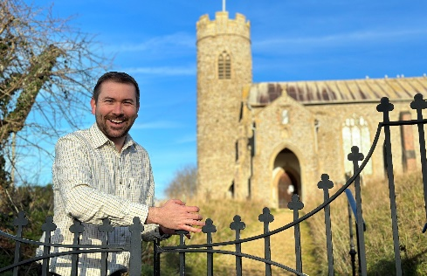


District Councillor Report – Cllr Callum Ringer
Serving the parishes of: Aylmerton ; Baconsthorpe ; Bodham ; East Beckham ; Gresham ; Hempstead ; Little Barningham ; Matlaske ; Plumstead ; West Beckham

Councillor Report November 2024
Fakenham Leisure and Sports Hub (FLASH)
North Norfolk District Council is delighted to confirm the £11m Fakenham Sports and Leisure Hub project will definitely go ahead.
The funding was initially granted by the previous Government under the Levelling Up Scheme - and NNDC has been waiting for this confirmation it would still be available following the change of Governments earlier this year.
The Ministry of Housing, Communities and Local Government have this week notified the Council that work on the £11m project can proceed after funding was given the green light in Wednesday’s Autumn Budget.
The Council has been granted £9.875m to build new facilities at Fakenham Sports Centre, including a 25-metre public swimming pool and improved outdoor sports facilities. Funding will enable the District Council to develop a full size 3G all-weather artificial grass pitch for competitive sports and outdoor sports changing facilities on the Trap Lane sports ground owned by Fakenham Town Council.
The current facilities, owned by the District Council and operated by leisure partners Everyone Active, currently comprises of a sports hall, fitness suite, multi-use area, dance studio, changing rooms and reception area. Alongside the new leisure offerings, an allocation of £1m has been made for carbon reduction measures to the existing Trap Lane facility.
Council awarded accreditation for domestic abuse support.
North Norfolk District Council have been awarded an accredited status by Standing Together, a domestic abuse support charity. Domestic Abuse Housing Alliance accreditation is the UK benchmark for how housing providers should respond to domestic abuse.
The Council works with DAHA to implement best practice as a housing provider/service, to ensure we are delivering a safe and effective response to domestic abuse. Locally, the Council works with the Norfolk Integrated Domestic Abuse Service (NIDAS), a specialist support service for those at risk of domestic abuse. North Norfolk District Council’s application and accreditation to DAHA was funded by Norfolk County Council
Important links:
If you are a victim of domestic abuse, feel unsafe in your relationship or housing arrangement, or need to talk to someone, there are several helplines available for you.
• Norfolk Integrated Domestic Abuse Service: 0300 561 0555
• 24 hour National Domestic Abuse Helpline: 0808 2000 247
• Leeway: 0300 510 077
• Respect Men’s Advice Line: 0808 810327
• Mankind: 01823 334244
If you are worried about your own behaviour and feel you may be putting your partner at risk you can ring Respect on 0808 8024040
If you need emergency support, ring 999 and ask for the Police. If it is too unsafe to talk, press 55 after dialling 999
NNDC Awarded GOLD RSPCA award for work with dogs:
North Norfolk District Council has again won a Gold RSPCA Pawprint award, for stray dog services.
Animal Warden Services deliver the Council’s stray dog service and work together with the Council as a key partner to help reunite owners and their dogs. The RSPCA’s PawPrint Award scheme celebrates and rewards local authorities and organisations for going above and beyond to deliver the highest quality animal welfare services.
The Council was also one of 13 organisations across England and Wales, who were awarded a gold award in the RSPCA’s new category for Kenneling. The Kenneling award commends high standards in the provision of kenneling services, ensuring that animals in temporary accommodation receive the highest level of care.
Norfolk Churches Trust sponsored Cycle Ride.
On September 14th myself and Kathryn took part in the Norfolk Churches Trust sponsored cycle ride. We set off with a target of cycling to 40 churches and raised £400 to be split between our nominated church (St Helen’s and All Saints, E&W Beckham), and the trust. The weather was kind to us on the day, but our generous sponsors were even kinder, and we managed to cycle to 50 churches and raise just short of £1000 (and it will be over that when gift aid is factored in!).
Thanks you to those of you who sponsored us, and well done to all those who took part, welcomed cyclists to a church or kept us fuelled by baking a cake. Our little part of Norfolk always seems to excel in the churches bike ride and long may that continue.
My penchant for signing up to challenges I may later regret continues, and I will be taking part in the Norfolk Marathon in April next year. I will be raising money for a local charity and my only aim is to complete it faster than Duncan Baker….

Steff Aquarone MP
In October I was pleased to begin working for our new MP, Steff Aquarone as a caseworker. This means that in effect, if you have any local issues, it will very often be me dealing with them. For expedience, you are welcome to come to me directly and I will be happy to help.
And Finally…. I continue to be available for any casework issues that arise so do get in touch if I can be of any assistance. Callum.ringer@north-norfolk.gov.uk

